

|  |
| --- |
| 30/31 Wicklow Street  Dublin 2  Ireland  Phone: +353 (0)1 6705978  Email: info@reactors.ie  Website: www.reactors.ie |

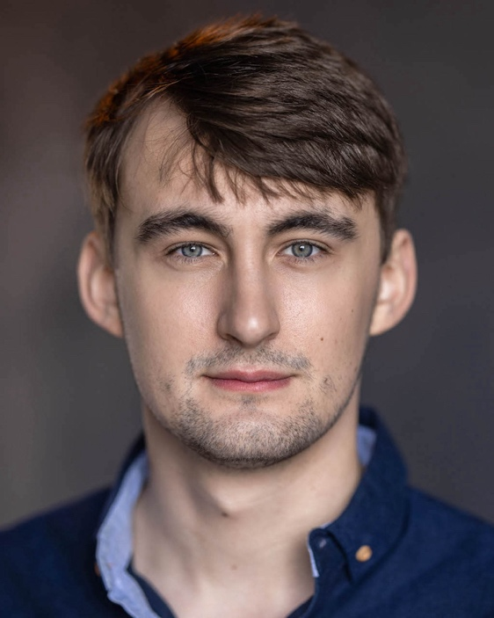

Culann McCarthy

|  |  |  |  |
| --- | --- | --- | --- |
| **Location:** | Dublin | **Eye Colour:** | Blue/Grey |
| **Height:** | 6’ 2” | **Hair Colour:** | Brown |
| **Playing Age:** | 20-29 | **Hair Length:** | Medium |
| **Appearance** | White | **Voice Quality:** | Authentic, Bold |

**Film/TV**

**(Year, Type, Role, TITLE, Company, Director)**

2024, Film I’M YOURS (RTE STORYLAND),Lone Man, Deadpan Pictures, Laura O’Shea

2024, Film *Power Ballad,* Student Director, 30 WEST, John Carney

**Stage**

**(Year, Type, Role, TITLE, Company, Director)**

2023, Stage, Lucentio, THE TAMING OF THE SHREW, St Enda’s Park, Sylvan Theatre

2023, Stage, Lewis, RIBBONS, The Mill Theatre

2023, Stage, Ray Dooley, THE BEAUTY QUEEN OF LEENANE, The Mill Theatre

2022, Stage, Number 4, BROS, Romeo Castellucci, The O’Reilly Theatre

2021-2022, Improv Group, IMPROV SHE WROTE, Various

**Accents & Dialects**: *(* = Native)*

Dublin South*, West Cork*, American-Southern States, American-Standard, Australian, Cork, English-Standard, RP, German,

**Languages:** *(* = Native/Fluent)*

English*, French (Basic)

**Music & Dance:**

Baritone

**Performance Skills**:

Improv, Good Ear for impressions, Debating

**Sports**:

Stage Combat, Brazilian Jujitsu, Sailing, Swimming

**Other Skills:**

Chess, Debating, Law Degree

**Training:**

Bow Street Academy, Full-Time Programme in Screen Acting, 1 year, 2023-2024

Ten Week Acting Course with The Lir 2022. Multiple Classes on Monologue Technique with Cathal Ryan 2022