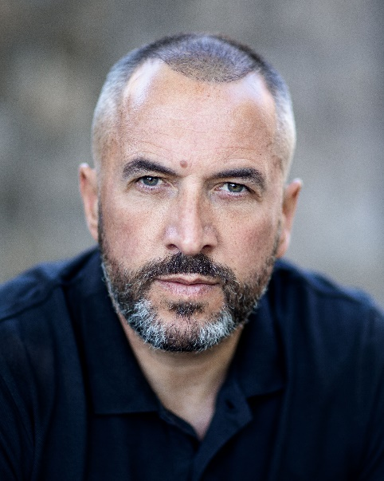

30/31 Wicklow Street

Dublin 2

Ireland

Phone: +353 (0)1 6705978

Email: [info@reactors.ie](mailto:info@reactors.ie)

Showreel: <https://www.spotlight.com/profile/>

Website: [www.reactors.ie](http://www.reactors.ie)

Rob McCarthy

|  |  |  |  |
| --- | --- | --- | --- |
| **Location: Dublin** |  | **Eye Colour: Hazel** |  |
| **Height: 6ft** |  | **Hair Colour: Black/Grey** |  |
| **Playing Age: 38 - 48** |  | **Hair Length: Short** |  |
| **Appearance : White** |  | **Voice Quality: Strong** |  |

Biography:

Rob is an actor & producer based in Dublin.

He has been most recently cast in season 2 of ’The Tourist’ for BBC and in 2023 he also features in a leading role in ‘The Irish Mob’ which is currently available on SKY, Amazon and Apple TV. He also plays the character of ‘Gerry’ in upcoming punk film ‘Dublin Crust’ due for release in the autumn of this year.

A Full time graduate from Bow Street Academy he began acting in 2010 and has appeared in many short films, commercials and features.

**Film & TV**

**Most Recent:**

**2023** – TV Series – ‘Hooded Man’ – ‘The Tourist Series 2’ – Amnesia Productions – Fergus O’Brien

**2023** – Feature Film – ‘Gerry’ - Dublin Crust – Sure Look Productions – Baz Black

**2023** – Feature Film – Valentino ‘Val’ Fagan The Irish Mob – Knightvision Productions & Avalon Films – Patrick McKnight

**2023** – Short Film – 6 minutes – ‘Tommy – Bus Driver’ - Suzanne Vachet – Actor as Creator

**2023** – Short Film – ‘Mike’ – INTERLOPERS – One Productions – Andrew Morphlock

**2023** – TV Series Documentary – Detective - Blood Detectives – Penninsula Tv

**2023 –** Feature Film – ‘Terry’ – The Sleep Experiment – Jackpot Productions – John Farrelly

**2022 –** Proof of Concept – Ransom 79 – John Kelleher Media –

**Producer Credits:**

**2023:** The Irish Mob AKA Dredges – 101 Films UK

**2023**: 6 Minutes – Actor as Creator Short Film

**2016:** The Closet – Short Film

**Accents & Dialects**:

Native – Dublin – Belfast – Irish RP

**Sports**:

Marathon Runner, Boxing, Cycling, Swimming.

**Other Skills:**

Driving Licence B, C, D, PSV Licence Holder

**Training:**

**2012 Acting for Camera 1,2,3 – Gaiety School Acting- Tutor Donal Courtney**

**2017-2018 Bow Street Academy Screen Acting – Full Time Graduate**